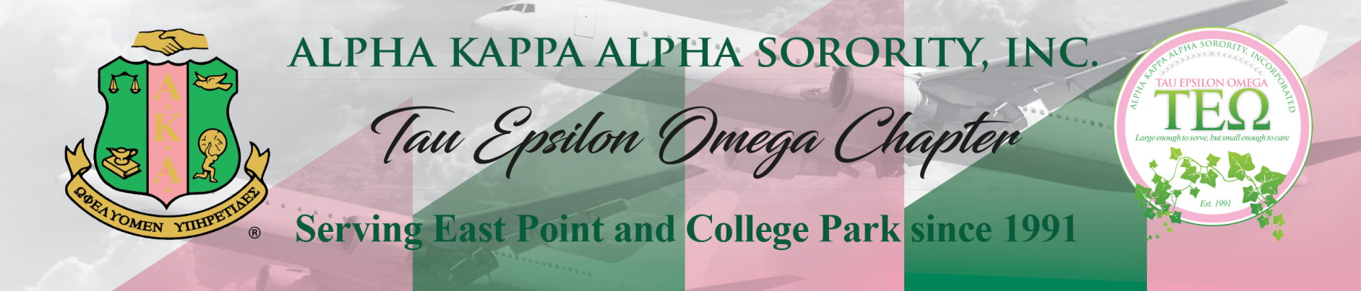
AKA Connection and Social Action Committee Meeting Agenda
Monday, May 1, 2023 at 6:30 PM
Meeting ID: 995 263 7222
Passcode: pinkivy
https://us02web.zoom.us/j/9952637222?pwd=aldZa0t2a0ExTEdZUDhlZWRTeWlEQT09

Summary: Article I, Section 15, (i) of the Constitution and Bylaws provides that: the Connection Committee “shall consist of a chairman and a representative from each region. The Committee shall identify and study national and international issues which impact quality of life, design strategies for communication with the membership regarding issues, and mobilize the membership for action to formulate and recommend position statements to the Supreme Basileus and/or the Directorate.
- Call to Order & Prayer
- Tiffany Moore Russell AKA Connection Award
- Voter Education Outreach Update
- Fulton County Voter Registrar Volunteer Opportunities
- State Election Board Monitoring/PPC POC
- 2023 Social Justice Forum Sub-Committee
Upcoming Meetings & Events
Date & Time | Subject | Location Information
Tentatively- May 18, 2023 @ 5:00 PM | Voter Education Outreach | The Gateway Center
May 27, 2023 @ 12:00 PM | Voter Education & Outreach | Greenbriar Mall

Contact Information:
Soror Catrice Windley
2022 AKA Connection & Social Action Chairman
678-206-4179/catricewindley@gmail.com

